Document Name - Kiosk - Meeting Rooms PRD

Version - 1.1 (clarifications added based on review comments)

Creator - Manvi Chandra

Reviewer/Approver - Ujjwal Trivedi

Classification - Internal Use Only

Kiosk for Meeting Rooms

Finding a perfect and available meeting room has always been a challenge for employees.

With Kiosk view, it will be easier to find and book meeting rooms without having to login to the web and app.
Few questions which Kiosk can answer is:
- Which room is available and free for me to use?
- Where is the room located?

Why?
- Reduce Meeting Room conflicts
- Improved Booking Experience - Auto unblock meeting rooms, book ad hoc meetings,
- Increase visibility

How will it help us?
- Helps to pitch products to clients who are looking specifically for Meeting Rooms Booking Solutions. Should help us widen the sales net.
- Most of the International clients, do not want to use Mobile app. This will help to grow our International customers, who can use kiosk app even if they do not use mobile App.

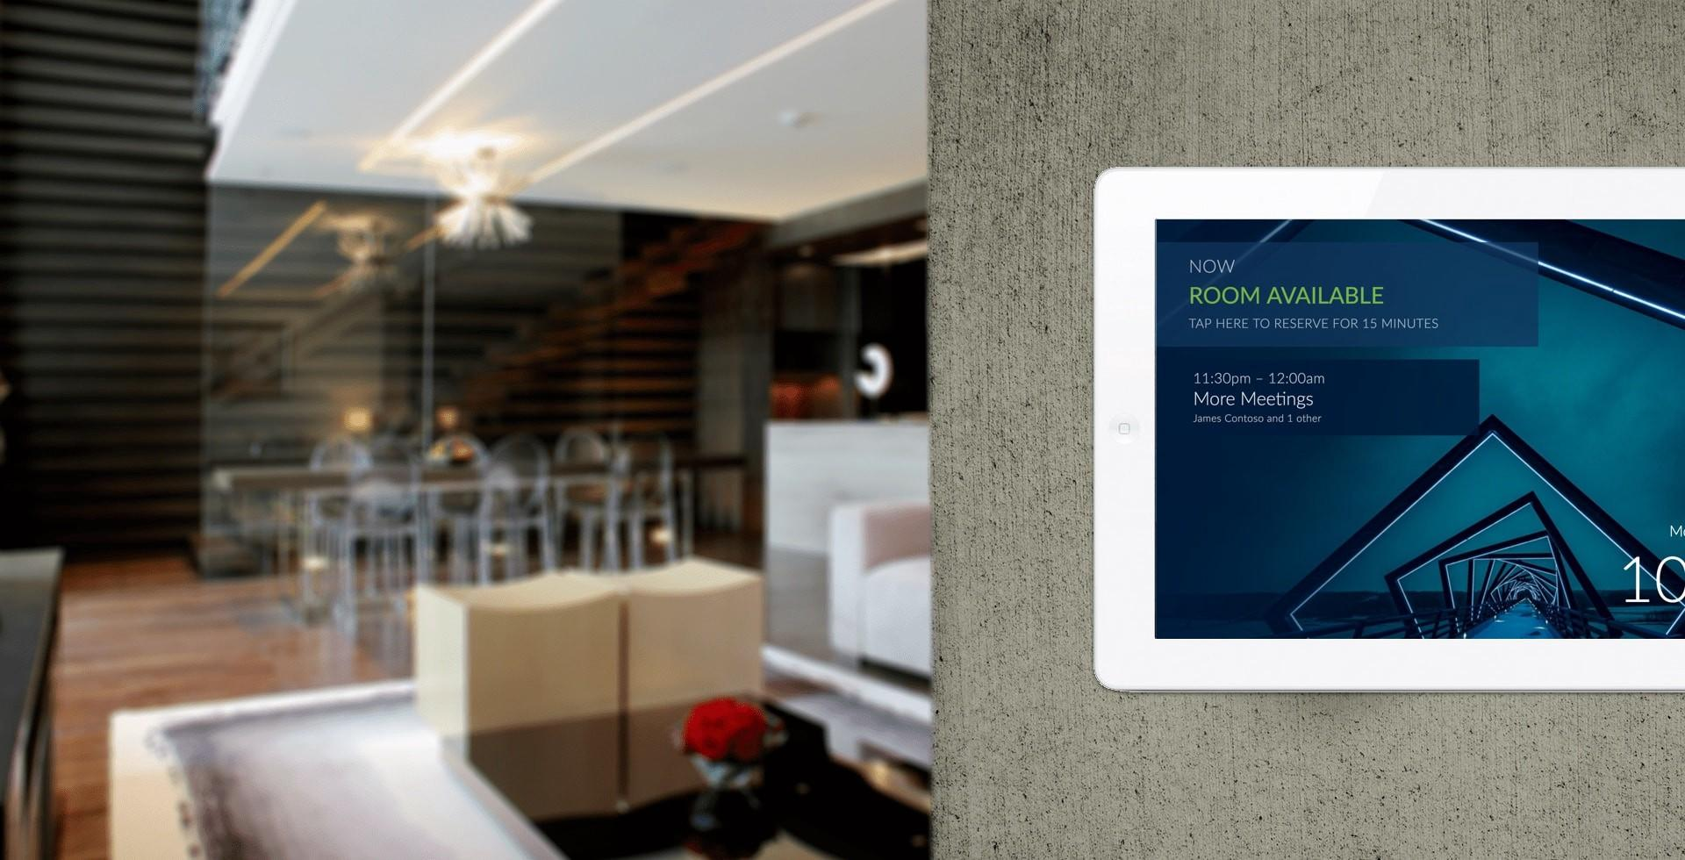

Meeting Rooms Kiosk Requirement

- This will be a native app.
- We will use a tenant specific code to map the kiosk application with the client URL.
- Once the kiosk application is mapped it will also ask the admin to connect to the calendar if not already done through the application. This will link the calendars only to the application.
- 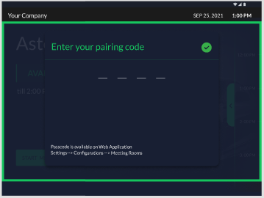
- Pairing code can be alphanumeric.
- Admin will not have to provide it’s credentials for login. Login to the kiosk application will be generic and based on the tenant specific code.
- The admin will be able to give consent on everyone's behalf, so that the employees can create meetings, and the same can be synced to the employee's calendar and to the meeting room’s calendar.
- When the admin logs in to the Kiosk, the admin will be asked to select the room for which the Admin needs to map the tab with.
- Admin also needs to enter an email ID. This way we use the combination of both pairing code and email ID.

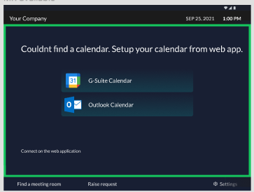
- The back navigation on the tab screen will take the user to the home screen of the application and not the tab.
- To switch the meeting room, the admin will have to enter a PIN number. This will be generated from the backend, and shared with the admin in the configurations window.
Help text : Passcode is available on Web Application Settings->Configurations->Meeting Rooms
For now we can use the same code for Pairing code and PIN for the use mentioned above.

Use Case 1
As a user I want to view from a distance, if the Meeting Room is “Available” or “In Use”.
The View will show the current/upcoming status of the meeting rooms.
- These status will be defined by the colors too, -green - available, orange - upcoming, red - booked/in-use
- The availability of the meetings will be as per system timezone(Tab timezone) and not the office time.
- If a meeting is created in another timezone on the outlook/google calendar, then also it should reflect as per system timezone.
- Ideally, there should not be any overlapping meetings, however in case if there is, sync the first meeting which was created.
- If the first meeting is removed or deleted, then only sync the second meeting.

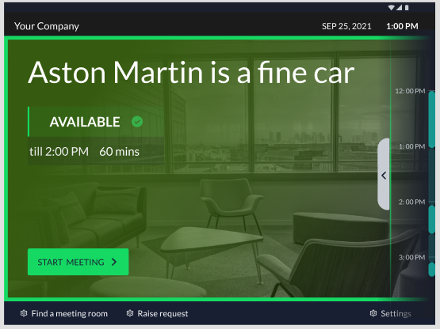

Use Case 2
As an employee, I want to book a meeting room urgently to attend an ad hoc meeting, and I can see that the room is empty.
https://www.figma.com/file/qVRgpvcZHEmCdE2IKJqvqb/Kiosk---Meeting-rooms?node-id=1903%3A47842
- Show the availability of the meeting room on the UI.
- The Kiosk view will show data related to the current(today’s) date only.
- Based on the colors also user will be able to identify from far, the status of the room
- The UI will be accessible for people with color blindness, the sidebar on the left of the screen would show different textures to show the usage of the room.
- The UI would show the meeting room Name, with the status of the room
- It would also show the time till what time the room is available.
- The UI would give an option to the employee to start a meeting right from the UI.
- User can either start a meeting from “ Book the Room” button or can create a meeting from side nav on the left side of the screen.
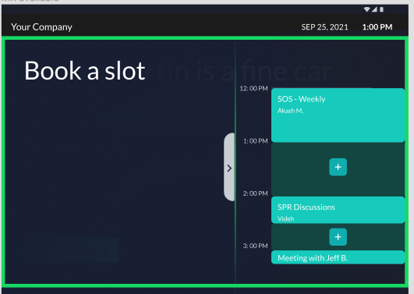
- This screen will show the meeting room calendar
- The side navigation would be configurable based on the meeting or time
If there is another meeting prior to the current time, show the meeting which falls within (-1 hour) of the time frame, and (+3 hours) from current time. This may not include the time of the 4th hour.
Example, the current time is 1:00 PM, then it will show the meeting before that, if the prior meeting was from 11:30 to 12:30, show that past meeting, but the past meeting should not exceed -1 hour of the time frame. For future time, show the meetings till 4:00 PM, but do not show the time of 4:00 PM on the time bar.
If the meeting is from 3:30 - 4:30, then the 4:00 PM time can be shown on the side bar.
If there was no meeting prior to the current time, show (-1) hour before the current time that is 12:00 PM
- Start time can never be more than End time. If user updates start time, the UI needs to block the user from updating end time less than start time. If user updates end time, user will not be able to update end time less than equal to start time.
- The calendar side pan will be scrollable. Scroll details available here.
- The user will be able to view Company Logo, by default we would not show any logo. If Client has already uploaded a logo in the WIS application, the same should reflect here.
The logo would be configurable. SHOW_LOGO_KIOSK - true, by default.
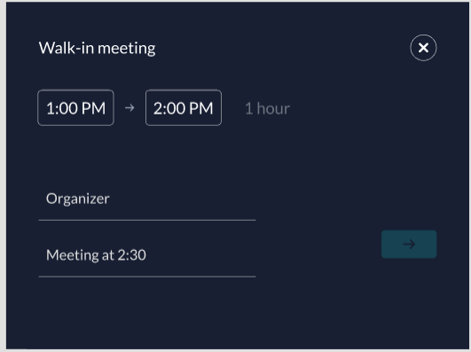
- The user will be able to view current time and date in the kiosk.
- When the user clicks on Start meeting. It will show the current time window of 1 hour to the user(if available) and the user can edit the time if required.
- Users will be able to edit the time range only for which the meeting room is available and has no other booking.
- The start time of the meeting can not be in the past.
- The end of the meeting will only show the time , till the time the meeting room is available.
- The user will be able to enter the organizer name and the meeting title. The max length of the meeting room title would be 100 characters. Meeting Title can have alphanumeric, special characters.
- Meeting title cannot be blank, if the user leaves it blank, It should be set as <Organizer’s Name> meeting.
- The user can also skip name details by just scanning the QR code. #P2.
- The default title of the meeting would be “<User’s Name> Meeting. Example “Choir’s Meeting”
- If the meeting room is booked by another user from any calendar or Web/Mobile Application during the time user is creating a booking, on clicking on next would show an error message, “Meeting room just got booked for the selected time”
- If the user is able to start the meeting, the blocked status of the room should also be visible on the calendar of the kiosk and should also sync back to the meeting room’s and Organizer’s calendar.
- Edge Case: If the user updates the timing of the ad hoc meeting from the user’s calendar. The meeting should be moved from the the current time to the suggested/updated time, however the meeting room will be released/made free from the current time, prior to that it will show booked. Example, if user created an adhoc meeting at 12:30 PM, and the user moves the meeting to 2:30 PM at 12:35 PM, then the meeting room will be released at 12:35 PM and the meeting will be created as a scheduled meeting for 2:30 PM.
- If user clicks on book a meeting at 11:35 AM and while creating a booking time changes to 11:37 AM, then the booking should be created from 11:37 AM.

Use Case 3
As an employee I want to book a room for later use

- If the room is available I can click on the arrow on right side window and create a booking by clicking on a + button 

- If the room is not available or shows an upcoming book then also the user will be able to book a meeting slot from the side pane.
- The side pane will be scrollable, and the user can select the slot from other slots which may not be currently visible on the screen.
- This view will be for the current date only. It will not show data for previous or next days.
- When the user taps on + button a new window is shown to create a booking however if a user wants they can also cancel and exit the screen


- When the user clicks on Start meeting. It will show the current time window of 1 hour to the user(if available) and the user can edit the time if required.
- Users will be able to edit the time range only for which the meeting room is available and has no other booking.
- The start time of the meeting can not be in the past.
- The end of the meeting will only show the time , till the time the meeting room is available.
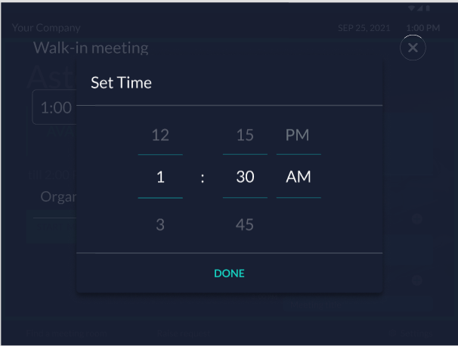
- The user will be able to enter the organizer name and the meeting title. The max length of the meeting room title would be 100 characters.
- The user can also skip adding the details by just scanning the QR code.
- The default title of the meeting would be “<User’s Name> Meeting. Example “Choir’s Meeting”
- If the meeting room is booked by another user from any calendar or Web/Mobile Application during the time user is creating a booking, on clicking on next would show an error message, “Meeting room is already booked for the selected time”
- If the user is able to start the meeting, the blocked room should also be visible on the calendar of the kiosk and should also sync back to the meeting room’s and Organizer’s calendar.
- After the booking is confirmed, it will show a pop that the booking is confirmed.
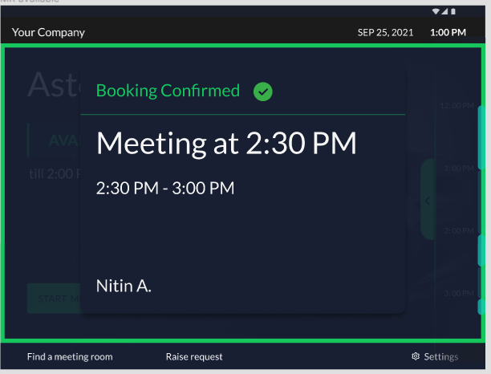

Use Case 4
As an employee I want to know when to check into the meeting room.
- Configure time to show upcoming booking. SHOW_UPCOMING_BOOKINGS_TIME : 5 minute, by default. This value will have Minimum and maximum value and the maximum value can be 5 minutes. This would mean if the meeting is at 5 PM, the check in option would show at 4:55 PM. If the previous meeting is till 5 PM, then also show the upcoming booking window, however the attendees of next meeting will not be able to checkin before 5:00 PM.
- To allow the release of the meeting room should be handled by RELEASE_MEETING_ROOM : true, by default. If false, the option of releasing the meeting room will not show up.
- The check in time should be configurable, this will be handled by the configuration MEETING_ROOM_RELEASE_IF_NO_CHECKIN - 15 minutes (by default) (External Property). This is the same property which will also be used on web/mobile app.This property will only be used if RELEASE_MEETING_ROOM is true. This property
- After this time, the meeting room will be released if not checked in. On UI the screen would go back to the Available screen, if there is no upcoming booking. On calendar - web - the meeting room will be released, booking will be removed from the meeting room but not from Organisers calendar. The room would send a notification to the organizer that it was released because no one checked in. It will be similar to what we are doing in Meeting rooms web booking.
- The user can click on checkin and start using the meeting room.
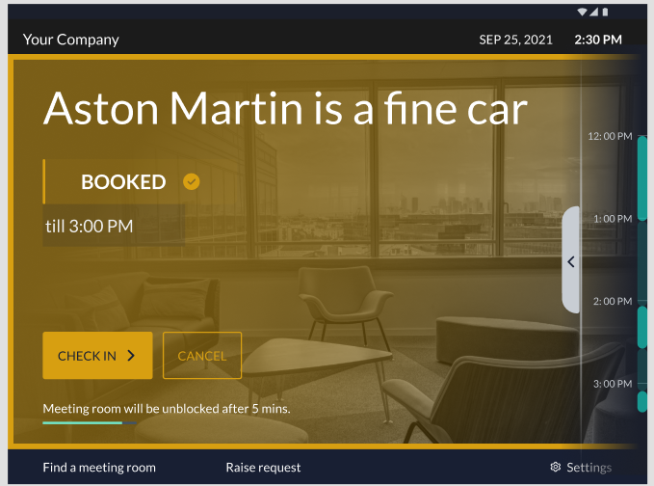
- The user can also cancel the meeting, however to cancel the meeting the user will have to give a PIN Number or scan the QR code to cancel the booking.
- Once cancelled the meeting room will be released, and the notification will also be sent to the invitees.
- Another employee can come and create another booking even if the UI shows an upcoming meeting, the user 2 will have to follow the steps similar to Use case 3.
- After the checkin, the meeting room kiosk will show the room status as in use/booked.
- The screen will show two options using which the user can end the meeting or extend the meeting.
- The user will be only be able to extend the meeting till the time there is no other meeting.

Use case 5
As an employee I should have an option to extend my meeting if required.
- Option to extend the meeting if the meeting room is in use. 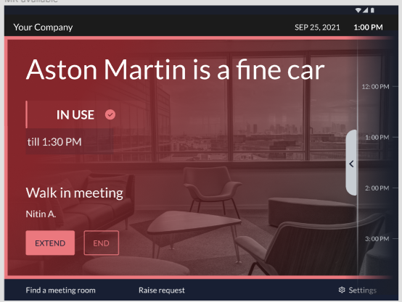
- The user will be able to extend the meeting till the time there is not a meeting.
- If there is another meeting, the user will not be able to extend the meeting beyond that time
- The extended meeting will also be updated on the room and every user’s calendar.
- The user will be able to end the meeting by giving a PIN number or by scanning the QR code. QR code can be skipped for V1.
- The PIN number to end or cancel the meeting will be triggered to the meeting organizer over Email. <Refer Email Template below>
- If the user doesn’t end the meeting, the meeting will be ended automatically after meeting time is over.
- When an employee cancels or ends the meeting, the meeting room will be freed up from that time.
- Extend button will not be highlighted if the meeting is in progress and there is already another meeting scheduled.

Static PIN for Employees -

Email to receive PIN
This Email will be configurable,MEETING_EMAIL_OTP_TO_AUTHENTICATE :true, by default.
Only if this is true, the authentication screen will be shown to the user and the Email will be triggered to the user.
This email will be triggered by no-reply@workinsync.io
The Email will be triggered to the Organizer of the meeting
Email content
“
Dear User,
PIN Number to end or cancel your meeting is <<PIN NUMBER>>.
This PIN is valid for meeting <<Meeting Title>> at <<Time , Timezone>>
Please do not reply to this mail. For any questions or concerns, please reach out to your office manager.
“

Non Functional Requirements

Performance

- The System should not take more than 1 second to load any screen on the Kiosk, as Kiosk has to be a very quick system to be used.
- Details on the Meeting Room Calendar pan should be available always, and not should not have any load time.
- All the screens should be responsive and should not be specific for a resolution.

Security
- Kiosk applications should not store/persist any Employee’s PII information locally.
- Admin login to connect calendars, should not store/persist Admin’s credentials on kiosk.
- Employee names, email, ID data should be handled as PII and transmitted and stored encrypted

Dependencies
- Integration of Calendars to Kiosk.
- Syncing of Rooms’ an Organizer’s calendars and events from Kiosk to Web and vice- versa
- Events can be checked in , End meeting, Cancel, Start Meeting.
- All the functionalities of the tab screen should not have any impact on the application. Employee should not be able to move away from the screen without putting any access code.

Success Metrics
- How many Clients are using Kiosk View? At Least 5 clients who are using Meeting Rooms Booking should use Kiosk View also.
ROI - ?
- How many clients are creating booking from Kiosk View?

Analytics
- Start_meeting_kiosk : This will update the count of adhoc meetings started from the Kiosk
- Booked_meeting_kiosk: This will update the count of bookings created from the Kiosk
- Checkin_meeting_kiosk: Count of meetings checked in on kiosk
- Bookings_meeting_room: Number of meetings created for a room from any source
- End_meeting_room: How many times a meeting has been ended by a user on a kiosk.
- Time_create_booking: total time it takes for an employee to create a booking from the Kiosk view.

Use case 6
As an employee I want to continue with my meeting but the current room is booked, so I would like to reserve another room.

- Unable to extend the meeting, select the “Find another meeting room” and this will show the available meeting rooms for now.
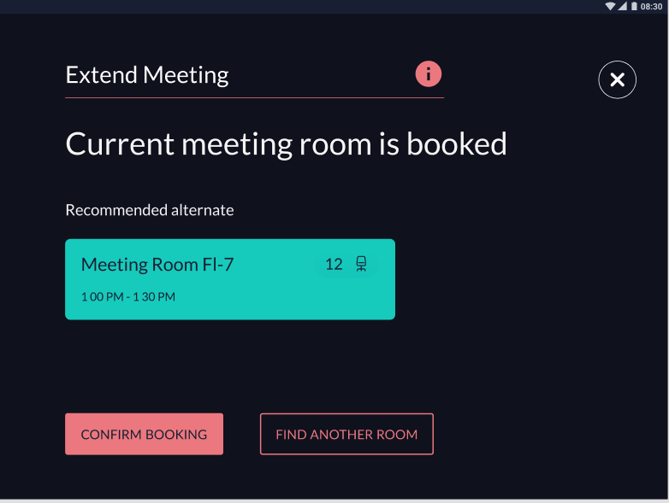
  - If room is not available to extend the meeting, the kiosk would suggest another room based on the following factors
    - Same floor, amenities, Capacity,and availability during the current time.
    - Users can select the recommended room or can go and find another room. The sorting of rooms will be based on
- Duration
- Capacity
- Same Floor
- Amenities
    - After room selection, data will be pre filled from the previous meeting.
    - After booking has been confirmed the user will be taken back to the home screen of the previous meeting room.
    - If there are no meeting rooms available, user will be asked to update the details to find another room.
- As a user I ‘ll be able to select a room from the list of meeting rooms and create a meeting for it.
- As a user I should be able to find the way to another meeting room

https://www.figma.com/file/qVRgpvcZHEmCdE2IKJqvqb/Kiosk---Meeting-rooms?node-id=2778%3A58840

Wrapper for Meeting Rooms Display
- Android and iOS application, to be available on play store or as an apk. These will be available on tablets only.
- For FireOS, android application or an apk should work
- The wrapper or the application should support,
  - Should be able to read and notify about battery health
  - Should be able to access camera, if needed
  - Should be able to communicate with external devices, if needed in future
  - Branding of WorkInSync

Use case 7<<P2>>
As an employee I should be able to raise any request with respect to the meeting room.

Use case 8
As an employee I want to checkin to the meeting room.
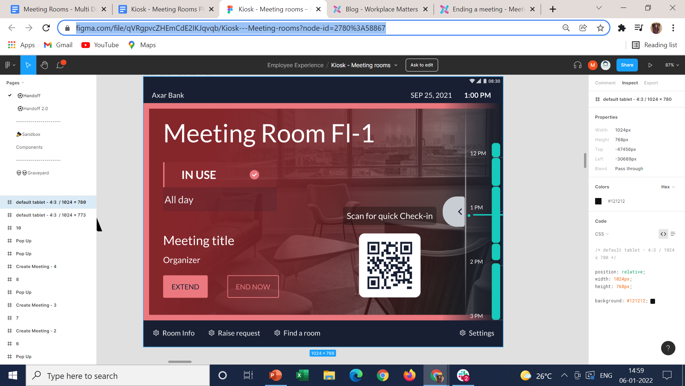
- A Qr code would be required for an employees to checkin to the meeting room
- Anyone(participants + Organizer) can checkin to the meeting rooms from Mobile app
- The kiosk status would change accordingly.
- If any one user checkins to the meeting room , only the meeting room status would change and the same would reflect on the kiosk and web, and the user who has checked in would be stored
- Other users who will not checkin that would show up as “No-Show” in reports and the utilization would be calculated accordingly.
- For the users who haven't checked in , the mobile app will still show the users to checkin to the meeting room.
- Employee checkin data captured would be sent to Meeting Rooms reports.
- The QR code will be unique for every room and Showing the QR code on screen would be managed by the configuration ShowQRonKiosk - true, by default. If false the QR code will not show up on the Kiosk . This will be configurable buid wise.
- The QR code will show up on every screen.
- The QR code can be used to checkin to the meeting, extend the meeting or End the meeting.

ADMIN Settings - KIOSK
- Disconnect the Calendar
- Connect another Room
- Logout
- Language #P2
- Orientation of the tab

Admin Settings - Backend
    - Manage all the tabs centrally - Status of tabs
    - An admin view to Manage the tabs and the devices and the status of the tabs -
    - PIN required to end a meeting or extend a meeting - This will be tenant specific.
    - Customizable background images on kiosk for every meeting room - This will be manageable from the Web application

Future <<P3>>
If there is an existing meeting of the user , and the user tries to create another meeting from Kiosk, The Kiosk should give an option to the user to assign a particular meeting to the room or create a new meeting.

Hardware Implication

- Tabs can be different and can have different make and model. Handle the hardware challenges, like the back button and other functionalities on the tab.
MDM Solution
- Manage kiosk
- Push Application/updates remotely
- Restrict usage to a single application
- API integration so that policies can be created from client site
- Mapping of Devices and policies - API integration
- App crash logs
- Device logs
- Battery Status
- Apple management - Supervised /unsupervised
- Support fire OS, android, kiosk mode, apple
- WIFI setup remotely - ApI integration
- Clients may have their own MDM Solutions

